Chapter 10
The Political Economy of Trade Policy

■ Chapter Organization
The Case for Free Trade
Free Trade and Efficiency
Additional Gains from Free Trade
Rent Seeking
Political Argument for Free Trade
National Welfare Arguments against Free Trade
The Terms of Trade Argument for a Tariff
The Domestic Market Failure Argument against Free Trade
How Convincing Is the Market Failure Argument?
Income Distribution and Trade Policy
Electoral Competition
Collective Action
Box: Politicians for Sale: Evidence from the 1990s
Modeling the Political Process
Who Gets Protected?
International Negotiations and Trade Policy
The Advantages of Negotiation
International Trading Agreements: A Brief History
The Uruguay Round
Trade Liberalization
Administrative Reforms: From the GATT to the WTO
Benefits and Costs
Box: Settling a Dispute—and Creating One
Case Study: Testing the WTO’s Metal
The End of Trade Agreements
Box: Do Agricultural Subsidies Hurt the Third World?
Preferential Trading Agreements
Box: Free Trade Area versus Customs Unions
Box: Brexit

Case Study: Trade Diversion in South America
The Trans-Pacific Partnership
Summary
APPENDIX TO CHAPTER 10: Proving that the Optimum Tariff Is Positive
Demand and Supply
The Tariff and Prices
The Tariff and Domestic Welfare

n Chapter Overview
The models presented up to this point generally suggest that free trade maximizes national welfare, although it clearly is associated with income distributional effects. Most governments, however, maintain some form of restrictive trade practices. This chapter investigates reasons for this. One set of reasons concerns circumstances under which restrictive trade practices increase national welfare. Another set of reasons concerns the manner in which the interests of different groups are weighed by governments. The chapter concludes with a discussion of the motives for international trade negotiations and a brief history of international trade agreements.
One recurring theme in the arguments in favor of free trade is the emphasis on related efficiency gains.
As illustrated by the consumer/producer surplus analysis presented in the text, nondistortionary production
and consumption choices that occur under free trade provide one set of gains from eliminating protectionism. Another level of efficiency gains arise because of economies of scale in production.
Two additional arguments for free trade are introduced in this chapter. Free trade, as opposed to “managed trade,” provides a wider range of opportunities and thus a wider scope for innovation. The use of tariffs and subsidies to increase national welfare (such as a large country’s use of an optimum tariff), even where theoretically desirable, in practice may only advance the causes of special interests at the expense of the general public. When quantity restrictions such as quotas are involved, rent-seeking behavior—where companies expend resources to receive the benefits from quota licenses—can distort behavior and cause waste in the economy.
Next, consider some of the arguments voiced in favor of restrictive trade practices. The arguments that protectionism increases overall national welfare have their own caveats. The success of an optimum tariff or an optimum (negative) subsidy by a large country to influence its terms of trade depends upon the absence of retaliation by foreign countries. Another set of arguments rests upon the existence of market failure. The distributional effects of trade policies will differ substantially if, for example, labor cannot
be easily reallocated across sectors of the economy as suggested by movements along the production possibility frontier.
Other proponents of protectionist policies argue that the key tools of welfare analysis, which apply demand and supply measures to capture social as well as private costs and benefits, are inadequate. They argue that tariffs may improve welfare when social and private costs or benefits diverge. In general, however, it is better to design policies that address these issues directly rather than indirectly through a tariff, which may have negative side effects. Students may better understand this concept by pointing out that a tariff is like a combined tax and subsidy. A well-targeted subsidy or tax leads to a confluence of social and private cost or benefit. A policy that combines both a subsidy and a tax has other effects that limit social welfare gains.
Actual trade policy often cannot be reconciled with the prescriptions of basic welfare analysis. One reason for this is that the social accounting framework of policy makers does not match that implied by cost-benefit analysis. For example, policy makers may apply a “weighted social welfare analysis” that weighs gains or losses differently depending upon which groups are affected. Of course, in this instance there is the issue of who sets the weights and on the basis of what criteria. Also, trade policy may end up being used as a tool of income redistribution. Inefficient industries may be protected solely to preserve the status quo. Indeed, tariffs theoretically can be set at levels high enough to restrict trade in a product.
Divergence between optimal theoretical and actual trade policy may also arise because of the manner in which policy is made. The benefits of a tariff are concentrated, while its costs are diffused. Well-organized groups whose individuals each stand to gain a lot by trade restrictions have a greater incentive to exert effort to influence trade policy. Though the aggregate losses of trade restrictions exceed the aggregate gains, the losses are much more spread out among a larger, but poorly organized group that has little individual effort to lobby against trade restrictions.

International negotiations have led to mutual tariff reductions from the mid-1930s through the present. Negotiations that link mutually reduced protection have the political advantage of playing well-organized groups against each other rather than against poorly organized consumers. Trade negotiations also help avoid trade wars. This is illustrated by an example of the Prisoner’s dilemma as it relates to trade. The pursuit of self-interest may not lead to the best social outcome when each agent takes into account the other agent’s decision. Indeed, in the example in the text, uncoordinated policy leads to the worst outcome because protectionism is the best policy for each country to undertake unilaterally. Negotiations result in the coordinated policy of free trade and the best outcome for each country.
The chapter concludes with a brief history of international trade agreements. The rules governing GATT are discussed, as are the real threats to its future performance as an active and effective instrument for moving toward freer trade. Also, the developments of the Uruguay Round are reviewed, including the creation of the WTO and the economic impact of the Round. Of note from this round was the phase-out of the Multi-Fiber Agreement, a set of tariffs and quotas on trade in textiles. Table 10-2 estimates that the phase-out of trade barriers in textiles has saved the United States roughly $11 billion since 2002.
The chapter also notes that more recent multilateral negotiations (the Doha Round) have failed, largely over disagreements regarding agricultural subsidies and trade. This has been a disappointment to free trade proponents as it marks the first time a major multilateral trade round has failed to produce a substantial agreement. However, the failure of the Doha Round can be partially attributed to the success of previous rounds of trade negotiations. As the world moves closer and closer to free trade, the marginal gains from further reductions in trade barriers become smaller. This is highlighted by Table 10-5 in the text, which shows that even under the most ambitious proposals in the Doha Round, the gains from freer trade would only be about 0.18 percent of global income.
The sources of failure of the Doha Round are echoed in the failure to enact the Trans-Pacific Partnership (TPP). Previous trade agreements had largely eliminated many traditional trade barriers like quotas and tariffs. The TPP focused on less concrete trade barriers like intellectual property rights and investor-state dispute settlement. As such, the simple logic of free trade was less resounding in advocating for this deal when balanced against its criticisms. Populist arguments that the TPP prioritized corporate interests over those of workers resonated politically and contributed to its failure. Similarly, the case of the UK’s departure from the European Union (Brexit) had less to do with concerns over free trade and more to do with another nontariff trade barrier: labor mobility. The cases of Doha, TPP, and Brexit suggest that the remaining barriers to completely free trade and full economic integration will be increasingly difficult to remove.

n Answers to Summary Questions (5, 6, 9)

5. If the main effect of DR-CAFTA was to increase clothing exports from the signatory nations to the United States, then the overall economic impact on the U.S. economy would be rather modest. Prior to 2004, the Multi-Fiber Arrangement (MFA) imposed quotas on textiles and apparel. As a result, these industries accounted for over 80 percent of the welfare costs of U.S. protectionism. However, the MFA was phased out in 2004 and the most recent estimate (see Table 10-2) puts the welfare costs of protection in these industries at only half a billion dollars. Thus, reducing trade barriers in clothing through the DR-CAFTA will only have a modest impact since trade in clothing has been pretty free since the end of the MFA.

6. The main problem with this view is that it assumes that the United States can pursue its own trade policies in a vacuum. Policies enacted in other countries will have effects in the United States just as U.S. trade policy will affect foreign countries. Thus, the United States has a legitimate interest in the trade policies of other countries, just as other countries have a legitimate interest in U.S. activities. Uncoordinated trade policies are likely to be inferior to those based on negotiations. By negotiating with each other, governments are better able both to resist pressure from domestic interest groups and to avoid trade wars of the kind illustrated by the Prisoners’ Dilemma example in the text.

9. One possible justification for subsidizing the domestic production of rare earth metals is the terms of trade argument for protection. Because China dominates the production of these metals, it has enough market power to impose an export tax on these metals and raise the world price (much as Saudi Arabia does with oil exports). This exercise of power could lead to a welfare gain for China at the expense of the rest of the world. By subsidizing domestic production, the United States could dilute China’s market power and reduce the threat of higher prices on rare earth metals. However, the assumption that China could benefit from an export tax assumes that there would be no retaliation in other industries. If China were to impose an export tax on rare earth metals, what’s to stop the United States from imposing an import tariff on electronics from China? Thus, the threat of China imposing an export tax is perhaps not as large as one might suspect given its market power in this industry.

Another potential justification for subsidizing domestic production would be if doing so would generate some social benefit in excess of the private benefit to producers. Perhaps there would be technological spillovers from mining these metals that would exceed any social costs of subsidizing domestic production. Of course, the opposite could well be true and the social cost of domestic production may be quite a bit higher than the social benefit given the large environmental impact of mining these metals. It is often difficult to pinpoint ex-ante which industries are subject to this kind of market failure and indirect intervention through trade policy may not be the best way to address these market failures.

n Answers to Textbook Problems

1. The arguments for free trade in this quote include:

• Free trade allows consumers and producers to make decisions based upon the marginal cost and benefits associated with a good when costs and prices are undistorted by government policy.

• The Philippines is “small,” so it will have little scope for influencing world prices and capturing welfare gains through an improvement of its terms of trade.

• “Escaping the confines of a narrow domestic market” allows possible gains through economies of scale in production.

• Free trade “opens new horizons for entrepreneurship,” creating opportunities for Filipino exporters to reach markets inaccessible without trade.

• Special interests may dictate trade policy for their own ends rather than for the general welfare. Free trade policies may aid in halting corruption where these special interests exert undue or disproportionate influence on public policy.

2. a. This is potentially a valid argument for a tariff because it is based on an assumed ability of the United States to affect world prices—that is, it is a version of the optimal tariff argument. If the United States is concerned about higher world prices in the future, it could use policies that encourage the accumulation of oil inventories and minimize the potential for future adverse shocks.

b. Sharply falling prices benefit U.S. consumers, and because these are off-season grapes and do not compete with the supplies from U.S. producers, the domestic producers are not hurt. There is no reason to keep a luxury good expensive.

c. The higher income of farmers, due to export subsidies and the potentially higher income to those who sell goods and services to the farmers, comes at the expense of consumers and taxpayers. Unless there is some domestic market failure (such as the subsidized good generating a positive externality), an export subsidy always produces more costs than benefits. Indeed, if the goal of policy is to stimulate the demand for the associated goods and services, policies should be targeted directly at these goals.

d. There may be external economies associated with the domestic production of semiconductors. This is potentially a valid argument. But the gains to producers of protecting the semiconductor industry must as always be weighed against the higher costs to consumers and other industries that pervasively use the chips. A well-targeted policy instrument would be a production subsidy. This has the advantage of directly dealing with the externalities associated with domestic chip production.

e. Thousands of home buyers as consumers (as well as workers who build the homes for which the timber was bought) have benefited from the cheaper imported timber. If the goal of policy is to soften the blow to timber workers, a more efficient policy would be direct payments to timber workers in order to aid their transitions to different industries.

3. Without tariffs or subsidies, we compute domestic production as S = 20 + (10 × 10) = 120 and domestic consumption as D = 400 − (5 × 10) = 350, for imports of 230.

a. To analyze the welfare effects of the tariff, it is helpful to draw a diagram for this small country. Note that since this is a small country, the tariff will not affect the world price, and the domestic price will rise by the full amount of the tariff, rising from 10 to 15.

After the tariff is imposed, domestic production will rise to S = 20 + (10 × 15) = 170 and domestic consumption falls to D = 400 − (5 × 15) = 325, for imports of 155. To analyze the welfare effects of this tariff, consider the diagram below. We know that, because this is a small country, the tariff will lead to a net welfare loss as the gains in producer surplus and tariff revenue are smaller than the losses in consumer surplus. The net loss from the tariff is highlighted by the shaded triangles representing deadweight losses from consumption and production distortions.

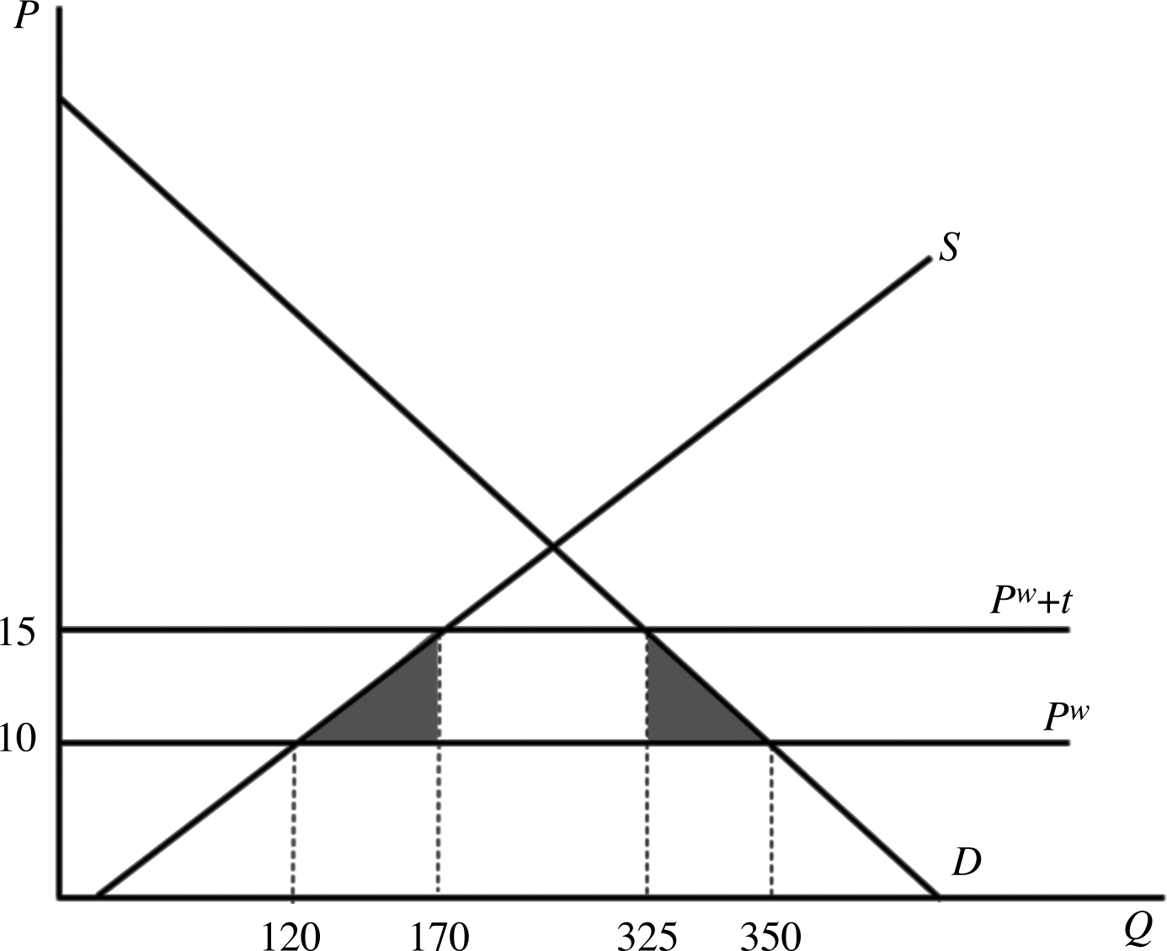

Computing the two deadweight loss triangles yields ½(5 × 50) + ½(5 × 25) = 187.5.

Against the losses from the tariff, we must consider the social gain from increased domestic production. After the tariff, domestic production increased by 50 units. The marginal social benefit from each unit of production is 10, so the social gain from increased production is 500. Thus, the net effect of the tariff on total welfare is 500 − 187.5 = 312.5.

b. A production subsidy would cause domestic supply to rise by S = 20 + 10(10 + 5) = 170, an increase of 50 units as with the tariff. However, the domestic price will not change in this country, so consumers do not lose any welfare with this subsidy. Rather, the only efficiency loss comes from production distortion costs, the leftmost triangle in the diagram above. The net loss of the subsidy is ½(5 × 50) = 62.5. However, the increase in domestic production caused social welfare to rise by 50 × 10 = 500, leading to a net welfare gain of 500 − 62.5 = 437.5.

c. The production subsidy is a better targeted policy than the import tariff because it directly affects the decisions that reflect a divergence between social and private costs while leaving other decisions unaffected. The tariff has a double-edged function as both a production subsidy and a consumption tax.

d. The optimal subsidy would be for producers to fully internalize the externality by raising the subsidy to 10 per unit. Supply would then rise to S = 20 + 10(10 + 10) = 220. The production distortion would now be ½(10 × 100) = 500, but the total social benefit from increasing production by
100 units would be 100 × 10 = 1000. The net welfare gain would be 1,000 − 500 = 500.

4. Refer back to the diagram in 3a. The gain in producer surplus from the tariff is equal to the area bounded above by the price of 15, below by the price of 10, and to the right by the supply curve. This area is equal to 725. Government tariff revenue is given by 5 times the quantity of imports = 5 × 155 = 775. Finally, the loss in consumer surplus is the area bounded above by the price of 15, below by the price of 10, and to the right by the demand curve. This area is 1,687.5. Total welfare from the tariff is
725 + 775 − 1,687.5 = 187.5.

However, if the government values every dollar of producer gain as worth $3 of consumer surplus, then from the government’s perspective, the net gain from the tariff is equal to:

Gain in Producer Surplus = 725

Political Gain in Producer Surplus = 725 × 3 = 2,175

Tariff Revenue = 775

Loss in Consumer Surplus = −1,687.5

Net Welfare Gain = 1,987.5

5.

a. This would lead to trade diversion because the lower-cost Japanese cars with an import value of €27,000 (but real costs of €18,000) would be replaced by Polish cars with a real cost of production equal to €20,000.

b. Before the addition of Poland to the EU, Japanese cars were not imported because their import price was €36,000. Thus, Poland’s addition to the EU would lead to trade creation because German cars that cost €30,000 to produce would be replaced by Polish cars that cost only €20,000.

c. This would lead to trade diversion because the lower-cost Japanese cars with an import value of €24,000 (but real costs of €12,000) would be replaced by Polish cars with a real cost of production equal to €20,000.

6. The United States has a legitimate interest in the trade policies of other countries, just as other countries have a legitimate interest in U.S. activities. The reason is that uncoordinated trade policies are likely to be inferior to those based on negotiations. By negotiating with each other, governments are better able both to resist pressure from domestic interest groups and to avoid trade wars of the kind illustrated by the Prisoners’ Dilemma example in the text.

7. The optimal tariff argument rests on the idea that in a large country, tariff (or quota) protection in a particular market can lower the world price of that good. Therefore, it is possible that with a (small) tariff, the tariff revenue accruing to the importing country may more than offset the smaller welfare losses to consumers, smaller because prices have fallen somewhat due to the tariff itself. Basically, a large country is able to get foreign producers to pay for part of the tariff in the form of a reduced world price.

8. The game is no longer a Prisoners’ Dilemma. As the chapter discusses, protectionist measures are welfare reducing in their own right. Each country would have an incentive to engage in free trade no matter what the strategy of the other country. Only in a more complex dynamic game in which a trade partner will only open its markets if the home country threatens sanctions (and the threats are only credible if occasionally carried out) would we find any welfare-enhancing reason to use a tariff.

9. The argument is probably not valid for a number of reasons. One reason is the domestic market failure argument. There is a lack of information regarding safety standards that leads a government to simply ban unsafe products, as opposed to letting consumers choose which risks they would like to take. Thus, it is consistent for the United States to ban unsafe products from China because U.S. regulators also ban unsafe products that are made in the United States. As for restricting products made with poorly paid labor, recall the discussions of the pauper labor argument and exploitation in Chapter 3. Wages reflect productivity, and hence, competition from workers in low-wage countries is providing goods in a sector that is relatively more expensive in the United States. Imports of these goods lift living standards in the United States. At the same time, foreign workers are being made better off relative to their autarky options, which are even more low paying than the “low” (relative to U.S.) wage jobs in the export sector.

